**Lab 3: Using EF Core CLI to Create and Apply Migrations**

1. **Install EF Core CLI (if not already):**

dotnet tool install --global dotnet-ef

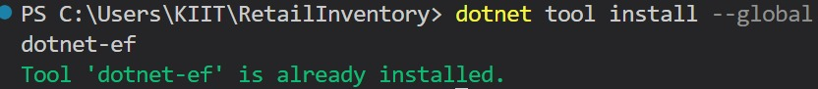

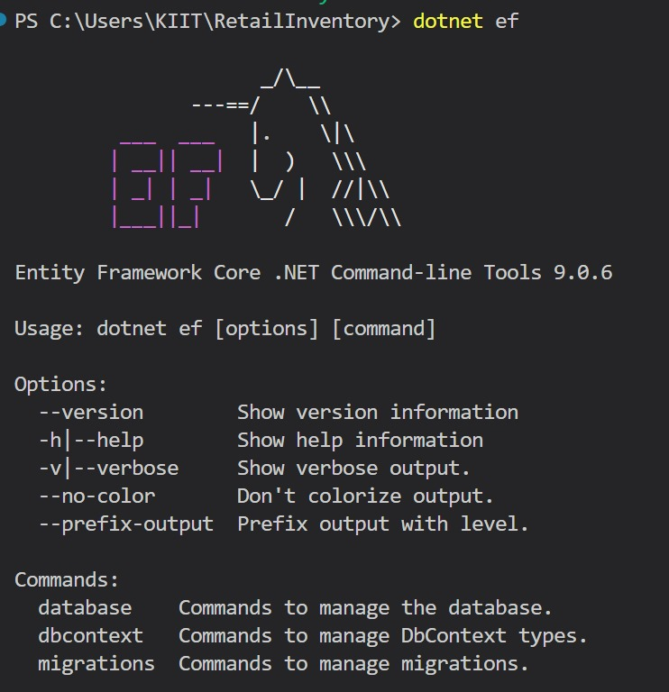

1. **Create Initial Migration:**

dotnet ef migrations add InitialCreate

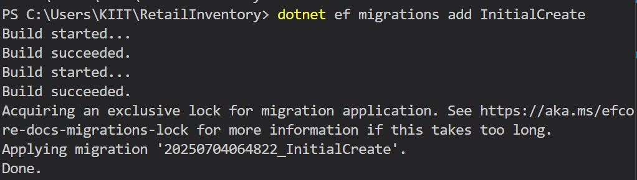

1. **Apply Migration to Create Database:**

dotnet ef database update

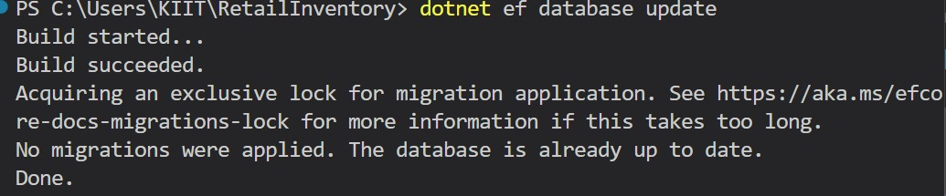

**4. Verify in SQL Server:**

Open SQL Server Management Studio (SSMS) or Azure Data Studio and confirm

that tables Products and Categories are created.

